How Chicken Farmers Keep It Cool
The summer months are here to greet us all with a rekindled respect for the power of air-conditioning. While many of us are cooling off in a pool or ice cream shop, chicken farmers are using the latest technology to keep their flocks comfortable and safe from dangerous heat while also minimizing their environmental footprint.
Keeping Things Cool with Ventilation
The modern chicken house uses large ventilated tunnels to keep birds cool. The house’s temperature is maintained by a master control system that adjusts ventilation based on the temperature measured at ground level. At this height, the farmer can be certain the cool air is reaching their flock.
Chicken farmer Terry Hollis, pictured walking his chicken house, explains that “static pressure” – opening the vents to allow the outside air to mix with the warm air before trickling down to the ground floor where the chickens are – is a helpful tool that farmers use to keep the flock comfortable.
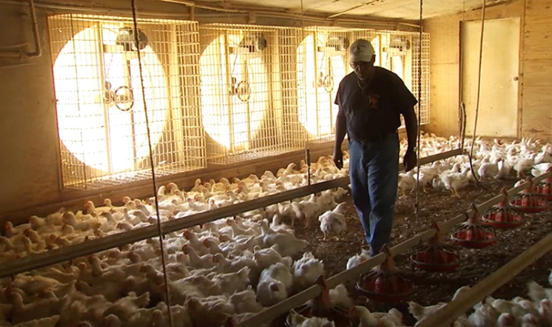
Want to learn more about chicken house ventilation systems? Our video gives you a first-hand look at this useful technology.
Keep the Flock Cool and Recycling Water with Cooling Pads
Evaporative cooling pads, another innovative technology used on many chicken farms, captures dew and rainwater. Natural or applied heat to the cooling pad releases this stored moisture and cools the chicken house on hot days. This process lowers farmers’ reliance on additional energy sources and can cut costs. “The cooling pads help to recycle water and save energy,” shares farmer Janice Vickers. Another chicken farmer, Terri Wolf-King, also implements cooling pad technology on her farm.
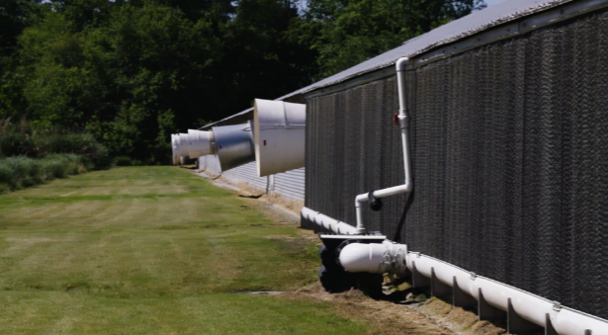
Keeping the Flock Hydrated with Waterlines
Farmers use waterline technology to get chickens the water they need while limiting waste or spillage throughout the year. These waterlines, referred to as nipple systems, allow farmers to be certain “the only water going into that house is going into the bird and not using unnecessary water.” With this technology, farmers can easily check that there are no leaks in the water and chickens are getting the H2O they need to stay healthy and cool.
Water conservation is a pivotal part of running a successful chicken farm. Farmers today monitor and record water usage to ensure their flock is receiving the essential amount of clean water. Wells and waterlines are sanitized on a regular basis. Farmers also implement other innovative practices to sustainably reduce, save and recycle water on their farms.
Want to see other innovative practices chicken farmers use to reduce, save and recycle water? Head over to our YouTube Channel.
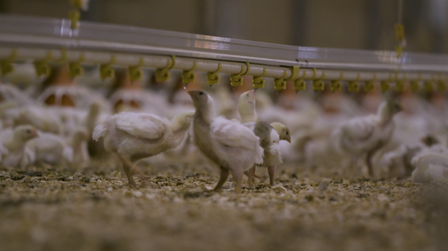
Temperature Tailored to Each Stage of Life
In order to provide the best care for the flock, modern chicken houses are outfitted with thermostats that allow farmers to adjust temperature settings to suit chickens through each stage of their life. When the chickens are about three weeks old, houses are kept at about 75 degrees Fahrenheit and the temperature gradually decreases to about 64 degrees Fahrenheit by week seven, to keep them cooler as they grow and emit more heat.
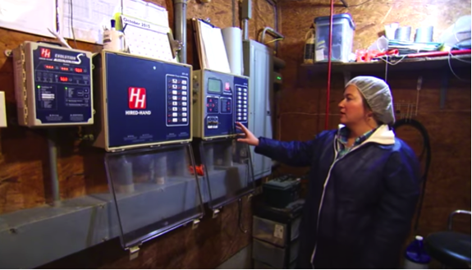
Like temperature, chicken feed is also tailored to each stage of a chicken’s life! You can read more about that on our blog.

